PROJECT DOCUMENTATION
SCRIPT-CONTROLLED ACL
Restrict Record Access Based on Field Value

1. Introduction
- Project Title: Script-Controlled ACL – Restrict Record Access Based on Field Value
- Team ID: SWTID-2026-1036
- Team Leader:
S. Smitha – 202400093@sigc.edu
- Team Members:
B. Manjusree – 202400226@sigc.edu
S. Mithra – 202400070@sigc.edu
A. Naazhini – 202400894@sigc.edu
- Platform: ServiceNow
- Project Type: Access control and record-level security

2. Project Overview
Purpose: This project demonstrates script-controlled Access Control Lists (ACLs) in ServiceNow to restrict record access unless users satisfy specified role and field-value conditions. In the sample scenario, users with the required role can access EEE branch records, while administrators retain full access.
Key Features:
- Restricts record visibility based on the Branch field value.
- Uses roles to control Read, Create, Write, and Delete operations.
- Allows administrators full access.
- Tests access by impersonating users with different role combinations.
- Demonstrates record-level security in lists and forms.

3.System Architecture
Platform: ServiceNow instance. Security layer: Script-controlled ACLs evaluate user roles and conditions. Data layer: custom table u_institution_details stores institution/student information.
- User requests to view or modify a record.
- ServiceNow evaluates the relevant ACL and required role.
- The ACL script checks administrator status and the user's assigned role.
- Access is granted or denied according to the ACL configuration.

4. Setup Instructions

Prerequisites
- ServiceNow instance with admin access.
- Security_admin role to create or modify ACLs.
- Permission to create users, roles, tables, and ACL records.

Milestone 1: Create User and Roles
Navigate to User Administration → Users and create a test user:
- User ID: EEE User
- First name: EEE
- Last name: User
- Email: eeeuser@gmail.com

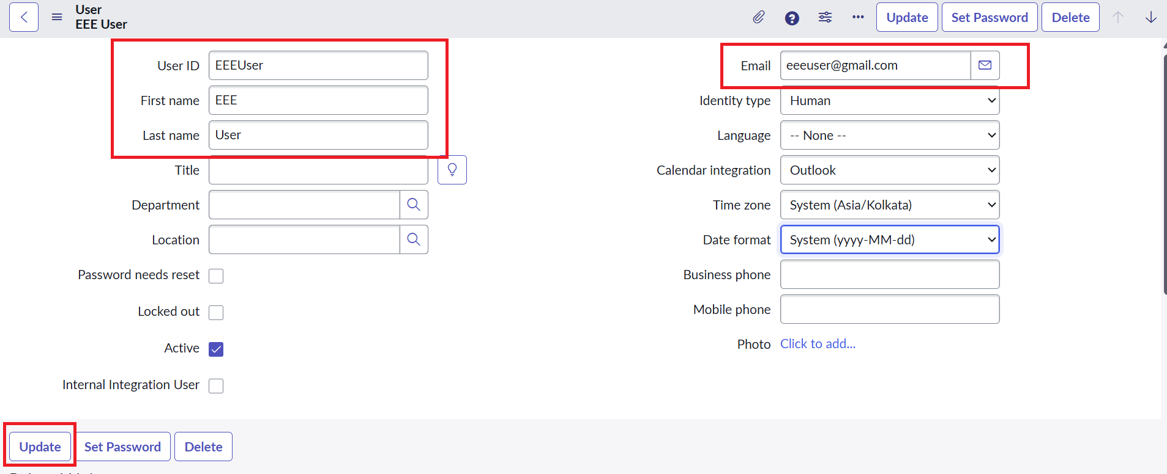
Under User Administration → Roles, create custom roles bb1, bb2, bb3, and bb4. Assign the required roles to the test user for testing.


Milestone 2: Create Custom Table
Navigate to System Definition → Tables and create: Label: Institution Details; Name: u_institution_details; Extends table: false.
Add these fields:
Field | Type
Student Roll Number | Auto Number
Student Name | Reference – User
Faculty Name | Reference – User
Branch | Choice: ECE, EEE, CSE
Email | String
Phone Number | String
Description | Multi-line string

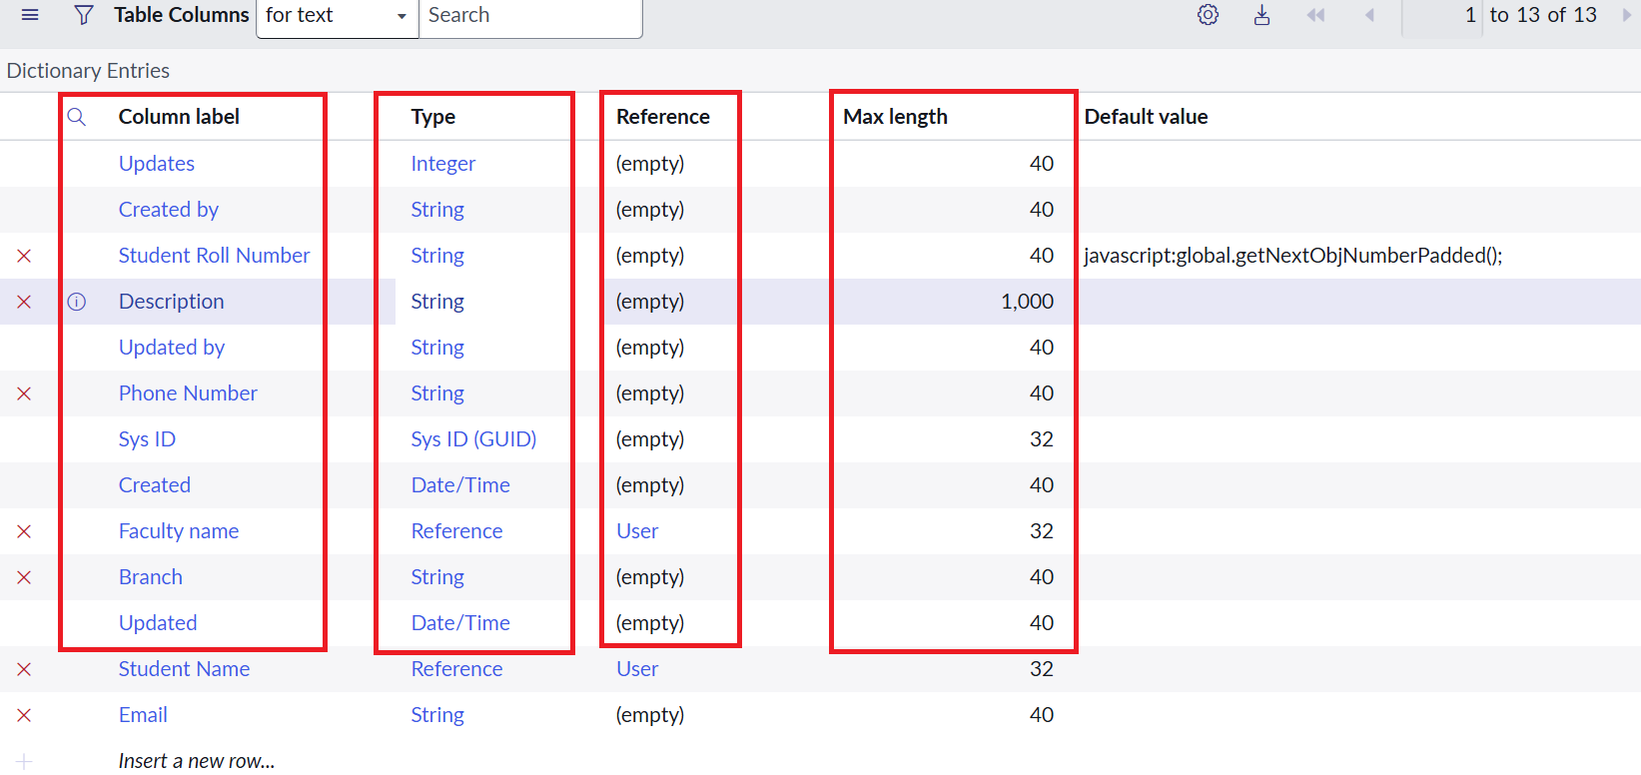Create multiple records with Branch values ECE, EEE, and CSE for access testing.

5. ACL Configuration

Read ACL (Script-Controlled)
- Navigate to System Security → Access Control (ACL) and elevate Security_admin.
- Create ACL: Type record; Operation read; Name u_institution_details; Active true; Advanced true.
- Add bb1 under Requires role. Set data condition: Branch is EEE.
- Enter the script below and submit.
(function () {
// Allow administrators full access
if (gs.hasRole('admin')) {
return true;
}
// Allow users with the configured role
if (gs.hasRole('bb1')) {
return true;
}
// Deny access to everyone else
return false;
})();
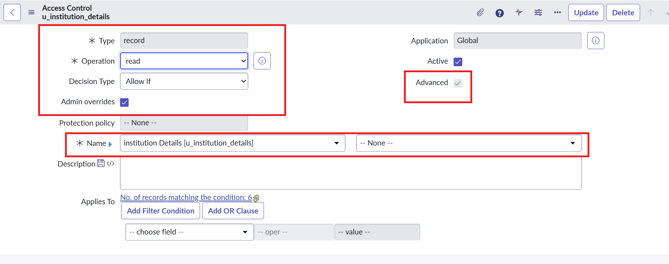

Note: The supplied lab specifies both the Branch is EEE data condition and a role-checking script.

5.2 Create ACL
Create a record ACL for u_institution_details with Operation create, Active true, and required role bb2. No data condition is specified in the reference lab.

5.3 Write ACL
Create a record ACL for u_institution_details with Operation write, Active true, and required role bb3. No data condition is specified in the reference lab.

5.4 Delete ACL
Create a record ACL for u_institution_details with Operation delete, Active true, and required role bb4. No data condition is specified in the reference lab.
Role progression described in the lab: bb1 for read; bb1 + bb2 for create; bb1 + bb2 + bb3 for write; bb1 + bb2 + bb3 + bb4 for delete.
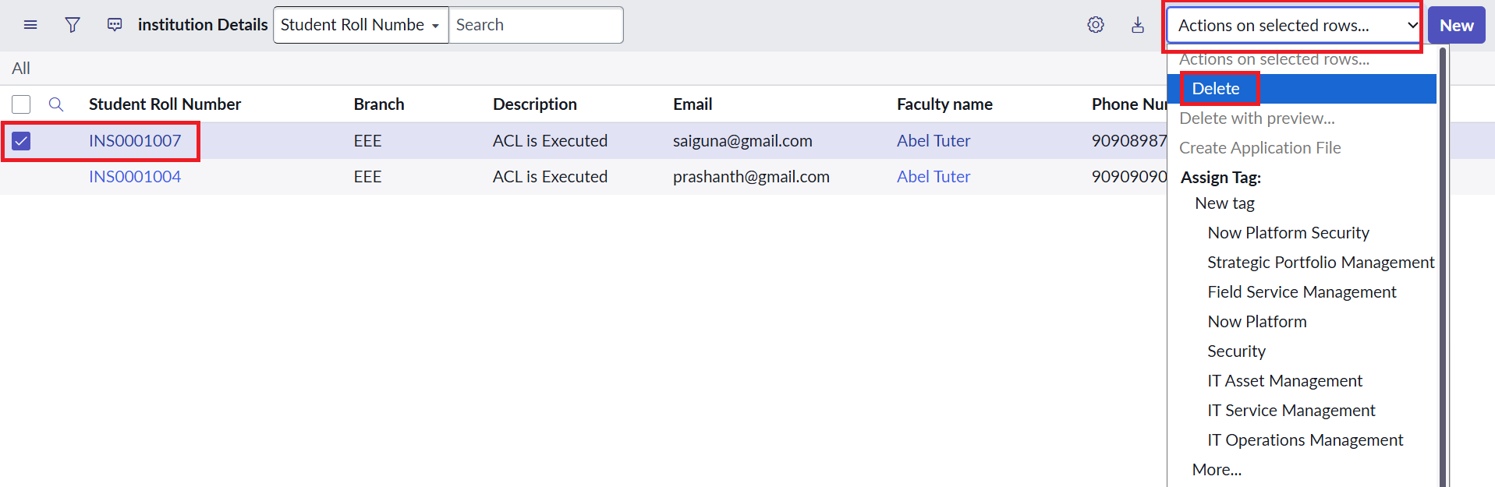

6. Folder Structure
This is a ServiceNow configuration-based project and does not use a conventional local source-code folder structure. Main components:
- Users and custom roles
- Custom table: u_institution_details
- Read, Create, Write, and Delete ACL records
- ACL scripts and table data records
- Test cases and screenshots

7. Running and Accessing the Application
1. Log in to the ServiceNow instance with authorized credentials.
- Open the Institution Details table/list (u_institution_details).
- Impersonate the EEE User and users with different role combinations.
- Open the list as an administrator to confirm administrative access.
The reference lab instructs opening the table list using the table name followed by .list in the Application Navigator.

8. Testing and Verification

Test Case | Expected Result (per reference)
User with bb1 | Can view EEE branch records; other records are restricted by the configured condition.
User without required role | Cannot view records.
Administrator | Can view all records regardless of branch.
bb1 + bb2 | Create capability / New button available.
bb1 + bb2 + bb3 | Can view and edit permitted EEE records.
bb1 + bb2 + bb3 + bb4 | Can view, create, edit, and delete permitted records.
Testing method: Impersonate each user, open the table list, and verify visible records and available actions.

9. User Interface
- Institution Details list view
- Institution Details record form
- ACL configuration form
- Impersonated user view
- Administrator view

10. Known Issues and Notes
- Access depends on correct ACL configuration, role assignments, and table/field names.
- The reference lab combines a Branch is EEE data condition with a role-checking script; verify behavior in the instance.
- The supplied reference does not provide screenshots or a public instance URL.
- Use test data when demonstrating access control.

11. Future Enhancements
- Extend access rules to additional branches and user groups.
- Add field-level ACLs for sensitive fields.
- Create repeatable tests for all role combinations.
- Maintain audit documentation for ACL changes and access testing.

12. Outcome
The project demonstrates how ServiceNow ACLs enforce record-level security through roles, field-value conditions, and scripts. It covers Read, Create, Write, and Delete operations and validates behavior by impersonating users with different permissions.
Reference basis: Cookbook project documentation was used for report structure; Script-Controlled ACL – Restrict Record Access Based on Field Value was used for the project-specific content.

13. Video Link https://drive.google.com/file/d/18Ir1yiyuxjg8prjkTC1SfEzSmw57M1n8/view?usp=drive_link

14. GitHub Link
https://github.com/Smitha-657/SCRIPT-CONTROLLED_ACL_NM.git

